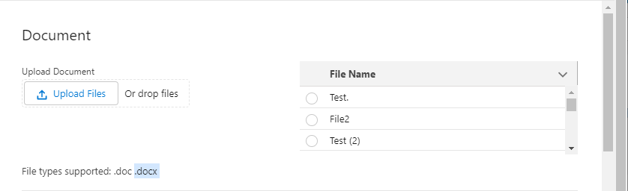

**Intake Form**

In itakeFrom Section, when we create a ticket then the upload file section adds in counterparty .

Newly added file upload section(Right side) is add.Do you want to add these to the counterparty as well?

This is testing of git